[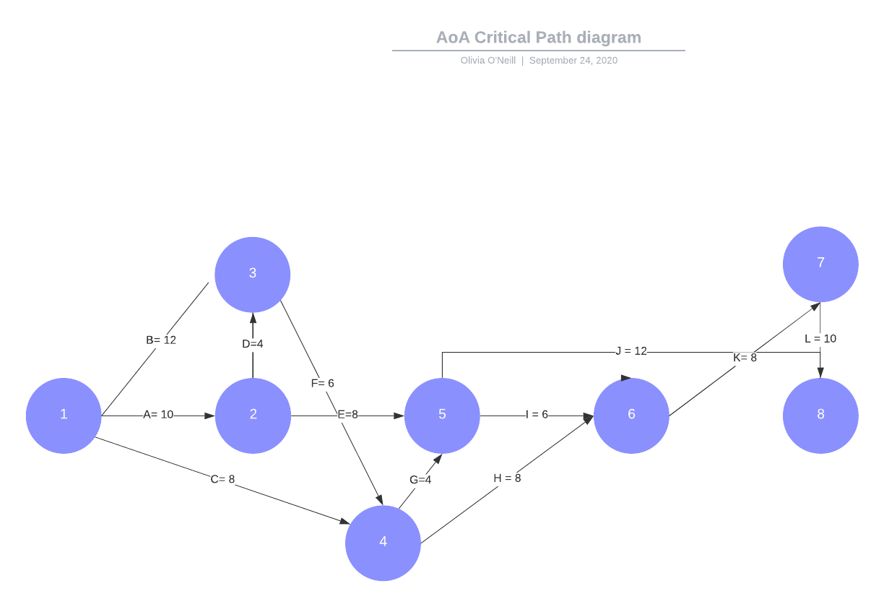](https://app.lucidchart.com/documents/edit/08798b82-bd91-41fc-a445-8de60b828de3/0?callback=close&name=docs&callback_type=back&v=451&s=612)

Path 1: A-E-J length= 30 days

Path 2: A-D-F-G-J length= 36 days

Path 3: A-D-F-G-I-K-L length= 48 days

Path 4: A-E-I-K-L length= 42 days

Path 5: B-F-G-J length= 34 days

Path 6: B-F-G-I-K-L length= 46 days

Path 7: B-F-H-K-L length= 44 days

Path 8: C-G-J length= 24 days

Path 9: C-G-I-K-L length= 36 days

Path 10: C-H-K-L length= 34 days

Critical Path: Path 3

The shortest amount of time it will take to complete this project is 48 days.